# Purpose

Technical Toolboxes Support Policy

The Technical Toolboxes Technical Support Policy as outlined in this document is the bedrock for Technical Toolboxes’ consistently excellent technical and engineering support. This policy governs the support process for all Technical Toolboxes’ support personnel, providing service guidelines and response requirements to help to ensure timely and

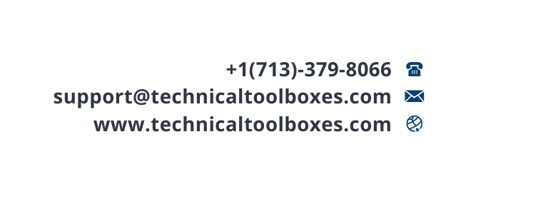

efficient resolutions to technical issues while maintaining customer satisfaction.

# Support Channels

Customers can reach out to Technical Toolboxes Technical Support through several channels:

* 1. **The Technical Toolboxes Help Desk**: Customers can go to the help desk directly (<https://technicaltoolboxes.atlassian.net/servicedesk/customer/portal/1>) to log a support ticket.

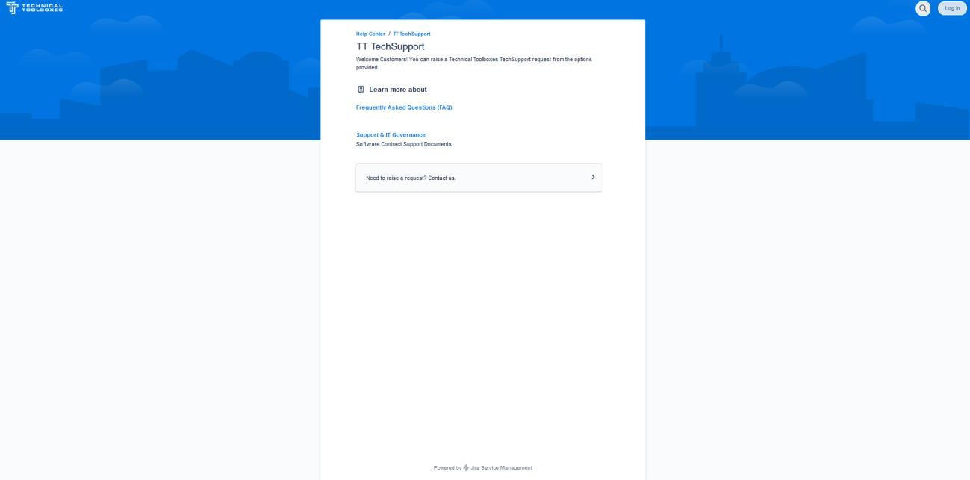

* + 1. 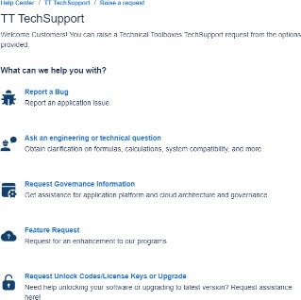On the desk, customers can submit a ticket by clicking on “Need to raise a request? Contact us”:
    2. Once signed in, customers can also view the status of their tickets via the “Requests” tab, in the upper left-hand corner:

* 1. **The Knowledge Center:** Customers can log a support ticket on our service desk via the Knowledge center ([https://ttwiki.azurewebsites.net/knowledge-base/contact-](https://ttwiki.azurewebsites.net/knowledge-base/contact-us/) [us/](https://ttwiki.azurewebsites.net/knowledge-base/contact-us/)), which can be reached via the “Contact Support” tab.

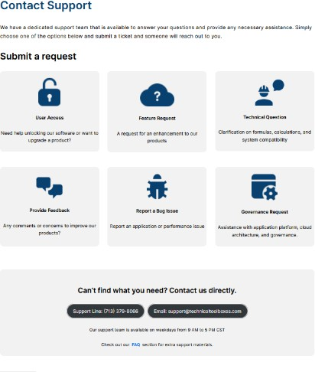

* + 1. The knowledge center also contains frequently asked questions which can also assist the user, in addition to the physics and tutorials behind many of our products.
  1. **Pipeline Hub:** A support ticket can be logged directly from Pipeline Hub ([https://pipelineengineeringsoftware.com/#/](https://pipelineengineeringsoftware.com/%23/)), once signed into the software. The option can be found in the blue question mark in the top header:

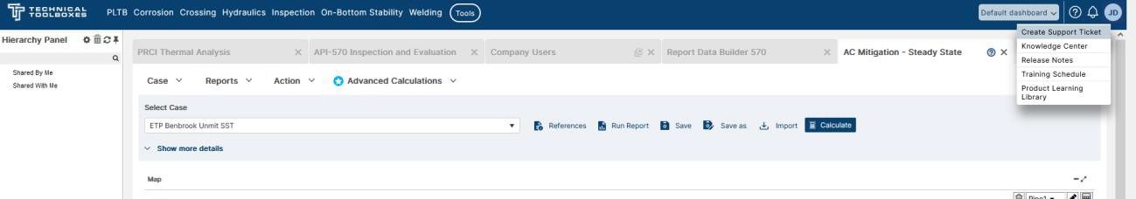

* + 1. Pipeline Hub is the main platform that hosts most of our products and

calculators; as such, users may frequently submit support tickets from this location.

* 1. **Email**: Users can also email [support@technicaltoolboxes.com](mailto:support@technicaltoolboxes.com) for assistance. The support desk will create support tickets to help address these requests, as

necessary.

* 1. **Phone**: Users can reach the support hotline via the phone number (714) 379-8066. Support desk personnel will create support tickets to help address these issues, as necessary.
  2. **On-Site Support**: Technical Support may include site visits (on-site with customer, or customer on-site with Technical Toolboxes.

1. Overview of the support desk

When creating a support desk ticket, users will be presented with five categories to file their request under:

Users are then requested to provide:

* 1. A summary of the problem
  2. A description going more in depth to the user’s request. Common features that expedite the analysis of a request include (if applicable):
     1. The company the user works for.
     2. Screenshots
     3. The software/component the request is focused on.
     4. An affected case name and/or report of a calculator.
  3. The component the user is referring to, if applicable.

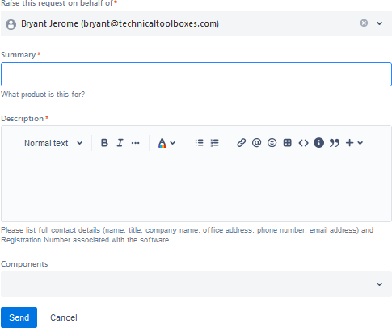

Upon creating a support desk ticket, a user will receive an email at the provided email address confirming that the support desk ticket has been created:

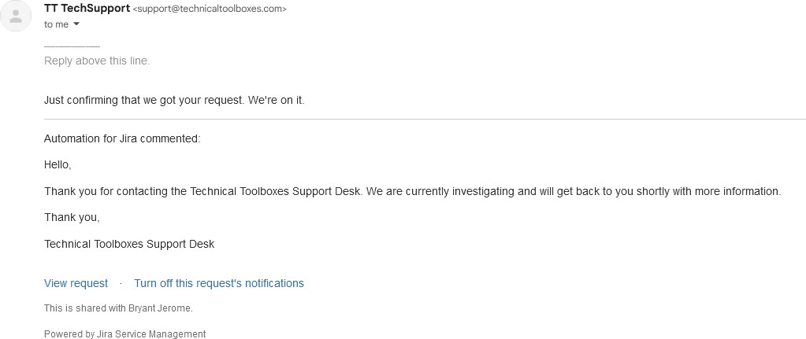

Users can use the “view request” button to view their ticket on the support desk. New users may need to reset their password to gain access to a newly created account. If you do not receive this invitation, please note the following:

* Customers should check with their internal IT Department to see if the message was marked as spam or rejected by any company internal rules or rights.
* The following IP ranges should be allowed:

o 167.89.0.0/17, 208.117.48.0/20, 50.31.32.0/19, 198.37.144.0/20, 198.21.0.0/21, 192.254.112.0/20, 168.245.0.0/17, 34.211.27.137,

34.211.27.236, 34.213.22.229, 34.249.70.175, 34.251.56.38,

34.252.236.245, 52.51.22.205, 54.187.228.111, 34.209.119.136,

34.211.27.82, 34.212.5.76, 34.253.110.0, 34.253.57.155, 35.167.157.209,

35.167.7.36, 52.19.227.102, 52.24.176.31, 54.72.208.111, 54.72.24.111,

54.77.2.231

Updates to the ticket will be forwarded to the user via email, in addition to the updates reflected on the ticket itself.

When a request is resolved, you will receive an email notification and can rate the level of service and include a comment. Technical Toolboxes always loves to hear feedback, and we appreciate our users commenting on our services.

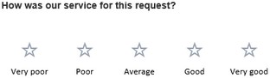

1. Who Can Request Support Services?

As a new customer, you can receive TT Technical Support Services as soon as you request to be properly licensed for TT software products. For existing customers, you can continue to request support so long as your account is in good standing. If you are using an older version of our software, you may be asked to migrate to a newer version as part of incident isolation or resolution.

1. Support Hours

Technical Support consists of assistance with support requests during standard business hours. Standard business hours are 9 a.m. to 5 p.m. CST. We make every effort to respond to your requests as soon as possible.

1. SLA (Service Level Agreements) and Response Times

Technical Toolboxes guarantees a response time and resolution time for all tickets filed on the support desk, based on the urgency of the ticket, and the tier that the client’s license

was purchased under. The request response and resolution times can be found in the chart below.

|  |  |  |
| --- | --- | --- |
| **Account Tier** | **Response time** | **Resolution Time** |
| **Basic** | 24 hours | High priority:10 business days Low priority: 20 business days |
| **Professional** | 8 hours | High priority: 5 business days Low priority: 15 business days |
| **Enterprise** | 4 hours | High priority: 3 business days Low priority: 10 business days |

High priority issues are defined as serious problems which can block progress, while low priority issues refer to all other requests.

Note that tickets in the basic and professional tier will still be completed as soon as

possible by Technical Toolboxes personnel; however, the guaranteed time for response and resolution is longer in both cases.

Additionally, it is noteworthy that a resolved bug means that the development team is aware of the issue the user ran into and has begun developing a fix, **not** that the bug has

necessarily been patched. Technical Toolbox’s support personnel will still strive to give the user a workaround by the specified resolution time before passing the issue to

development, however.

1. Knowledge Center

We encourage our users to use our knowledge center that provides information, articles, and solutions for our products. You may find the help you need without raising a request. You can access the knowledge center via the following link:

https://ttwiki.azurewebsites.net/

1. Privacy Recommendations for Working with Support

When providing information for a Support request, you should only provide TT (Technical Toolboxes) with information required to provide Support, and which is clear of confidential or other sensitive information. TT does not require Protected Health Information (PHI), Payment Card Industry (PCI) information, or Personally Identifiable Information (PII) to provide Services and you should not forward any of such types of information to TT in connection with a Support request. At all times, information provided to TT during Support will be handled in accordance with the Privacy Policy available here:

https://[www.technicaltoolboxes.com/privacy-policy/](http://www.technicaltoolboxes.com/privacy-policy/)